Purpose of an Ecomap
Analysing Relationships: Ecomaps are essential for examining the nature and intensity of an individual's relationships. They extend beyond family connections to cover various social interactions, offering insights into family dynamics and the mix of supportive and challenging aspects within the family.
Identifying Support and Stress Sources: Ecomaps are instrumental in identifying where support and stress come from, highlighting both positive and negative influences. They assess each family member's links to social support systems, such as housing, income support, counselling, and justice programs, and evaluate the quality of these links.
Providing a Comprehensive Overview: Ecomaps offer a wide-ranging view of a person's interactions with their surroundings, including community ties like friends, neighbours, clubs, and spiritual groups, as well as the family's overall engagement with the external environment.
Enabling Customised Interventions: The detailed insights from ecomaps help social workers devise tailored interventions. They identify areas needing more resources or support and check for any overlap in services to ensure efficient and effective assistance.
Creating an Ecomap
Begin with a Central Circle: On a whiteboard or paper, draw a large circle in the centre, labelling it with the client's name.
Identify Key Elements: Encourage the client to list various aspects of their life, such as:
- Family Members: Immediate and extended family, including parents, siblings, grandparents, and other relatives.
- Friends and Peers: Close friends, acquaintances, and peers who play a role in the client's social
- Educational or Work Connections: Teachers, classmates, colleagues, and supervisors, indicating the client's engagement in educational or occupational settings.
- Healthcare Providers: Doctors, therapists, or other medical professionals involved in the client's health care.
- Community Resources: Local community services, support groups, clubs, or organisations that the client interacts with.
- Spiritual and Cultural Connections: Religious leaders, places of worship, and cultural groups that are part of the client's life.
- Recreational Activities: Clubs, sports teams, or hobbies that the client participates in.
- Support Services: Social workers, counsellors, legal advisors, or other professionals providing support.
- Neighbours and Local Community: People in the client's neighbourhood or local community who have an influence or relationship with the client.
- Online and Digital Connections: Online communities, social media connections, and digital platforms that are part of the client's social network.
Map Out Relationships: Surround the central figure with smaller circles for each person or service identified, representing their connections. You could have different shapes or colours for adults/children or for different genders. Remember to add a key.
Depict Relationship Quality: Use varied lines to show the nature of each relationship:
- Solid or thick lines for close and strong relationships, like family members, best friends, or a supportive colleague
- Broken lines for less close or occasional relationships, like acquaintances, distant relatives, or professionals the service users meets sometimes.
- Lines with crosses for difficult or stressful relationships, such as a challenging family member or a problematic work relationship.
Indicate Resource Flow with Arrows: Arrows show the direction of resources, energy, or interest.
- Double-ended arrows show relationships where both people help and support each other equally.
- Single-ended arrows point from one person to another, showing that one person is giving more support or influence in the relationship than they receive.
Add Descriptive Words: Beside the lines or smaller circles, add a word or two to further explain, clarify, or emphasise the information on the ecomap.
Date the Ecomap: Record the current date on the ecomap for reference.
Update as Needed: Since ecomaps are dynamic, they should be regularly updated to reflect any significant changes since the last review.
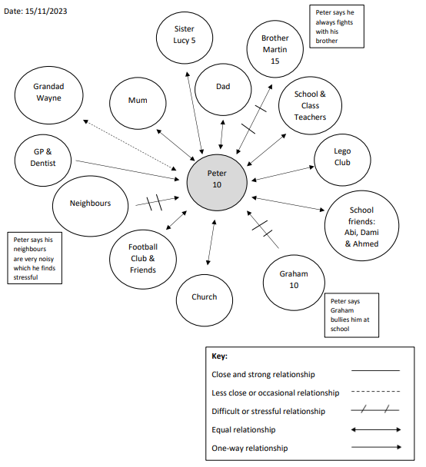
Examples of Questions for a Child Family and Home
Life:
- "Who are the people you live with?"
- "Do you have any brothers or sisters? What are they like?"
- "Tell me about who takes care of you at home." School, Friends, and Best Friends:
- "What do you like about your school? Who are your friends there?"
- "Who are your closest friends and what do you enjoy doing together?"
- "Is there a teacher or someone at school you feel comfortable talking to?"
Hobbies and Interests:
- "What do you love to do when you're not at school?"
- "Are there any activities or hobbies you really enjoy?" Community and Neighbourhood:
- "Do you know the people who live near you? What are they like?"
- "Are there any special places near your home where you like to go?" Clubs and Groups: • "Are you part of any teams or clubs, like sports or music?"
- "What happens in those groups, and who else is there with you?" Supportive Figures:
- "Who do you talk to when you feel upset or have a problem?"
- "Is there someone you love sharing good news with?" Routine and Daily Life:
- "What's a normal day like for you after school?"
- "Who do you spend time with on weekends or holidays?"
Health and Care:
- "Do you visit a doctor or dentist? What's that like?"
- "Who looks after you when you're not feeling well?"
Emotional Connections:
- "Who or what makes you feel really happy?"
- "Is there anyone you miss or wish you could see more often?"
Safety and Comfort:
- "Are there places or people where you feel safest?"
- "Is there anything that worries you or makes you uncomfortable?"

